**Installing ColdFusion 8 on Windows**

A few months ago I posted an article on [Installing Apache on Vista](http://www.simonwhatley.co.uk/installing-apache-on-vista), and it proved to be extremely popular. It appears that I was not the only one who found it a non trivial matter.

Now it is the turn of ColdFusion 8. ColdFusion 8 as we well know is the latest and greatest incarnation of the ColdFusion platform from Adobe. It has a lot of great new features such as cfimage, cfzip, cfexchange, some contentious features such as cfthread and cfinterface, and some not-so-necessarily-cool new “Web 2.0″ features such as cffeed and cfajax. But since this article isn’t about any of these, I better stick to the topic.

Like my article on installing Apache, installing ColdFusion on Vista is again not a trivial matter and involves only what can colloquially described as a “shed load of steps”. I’m probably being a little harsh towards ColdFusion as many of the problems I encountered were more closely related to Apache than ColdFusion.

NB: This article will assume that you have pre-installed Apache (although you could use IIS if so compelled), turned off Vista’s User Account Control (UAC), disabled any firewalls you have installed and finally, but most importantly, [you have downloaded ColdFusion from the Adobe website](http://www.adobe.com/products/coldfusion/).

Let us begin.

1. Find where you downloaded your copy of the **ColdFusion Installer**. Right-click on the executable file and specify to “Run as Administrator”. The installer should start and you should see the screenshot below. Select “English”, or which ever your language preference is, and Click “OK”.

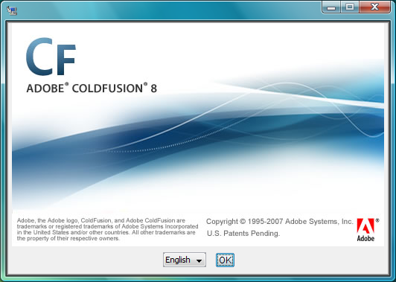

1. The **ColdFusion Installation** progress screen may or may not be briefly displayed.

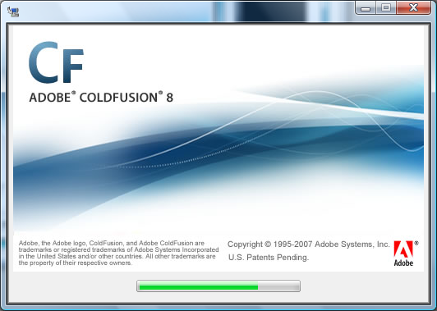

1. The **Introduction** screen will be displayed. Click “Next”.

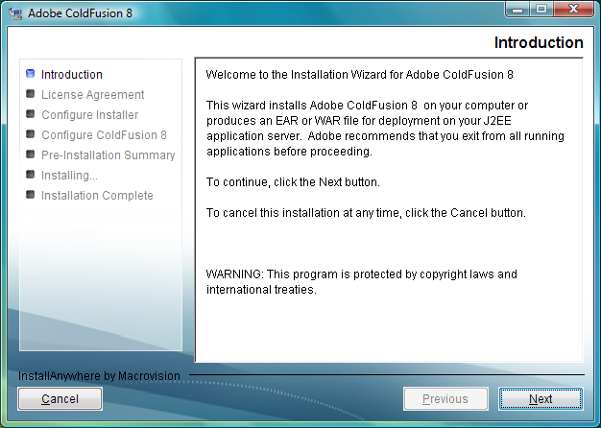

1. The **License Agreement** screen will then be displayed. Agree to the “I accept the terms of the License Agreement” and Click “Next”.

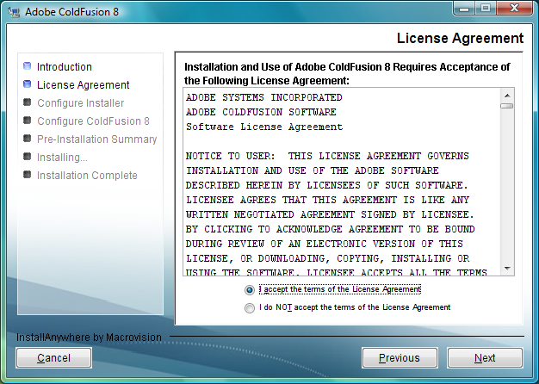

1. The **Install Type** screen is then displayed. You don’t need to enter a serial number unless you are installing this into a production environment. Check “Developer Edition” and Click “Next”.

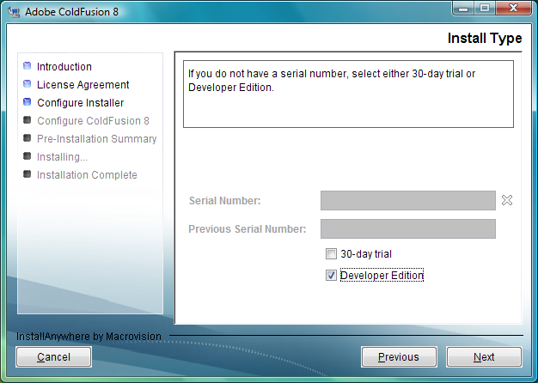

1. The **Installer Configuration** screen should be displayed. Since we already have Apache 2.x installed as our web server (if you want to use IIS, you will need to skip steps 11.1 and 11.2), check “Server configuration” and Click “Next”.

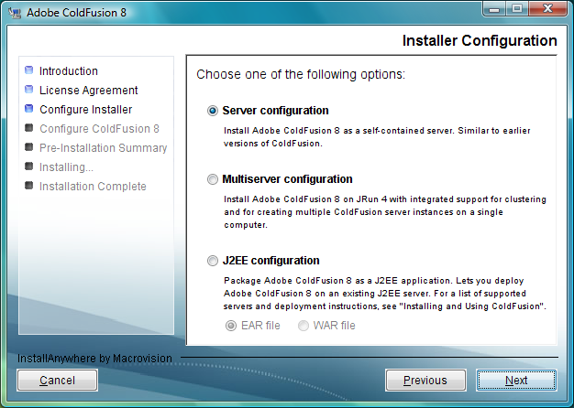

1. The **Sub-component Installation** screen should be displayed. This is one of the noticeable changes from version 7 to version 8 of ColdFusion. Hovering your mouse over each sub-component will describe in more detail what each sub-component does. If you plan to integrate .NET (especially with WebServices) or carry out Flex development then make sure that the “.NET Integration Services” and “LiveCycle Data Services” items are checked. For simplicities sake, check everything and Click “Next”.

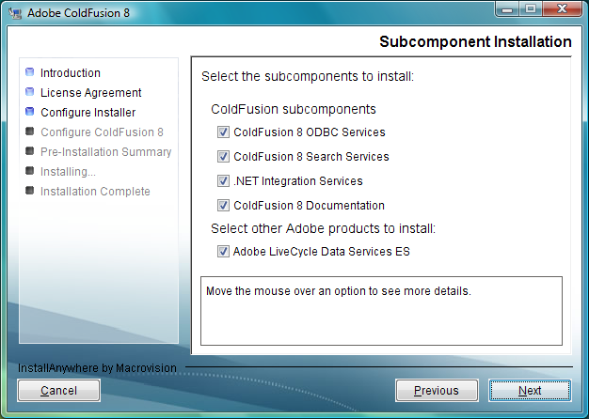

1. The **Select Installation Directory** screen should be displayed. The default directory for a Serverconfiguration will be “C:\ColdFusion8″ on a Windows machine. Click “Next” to continue.

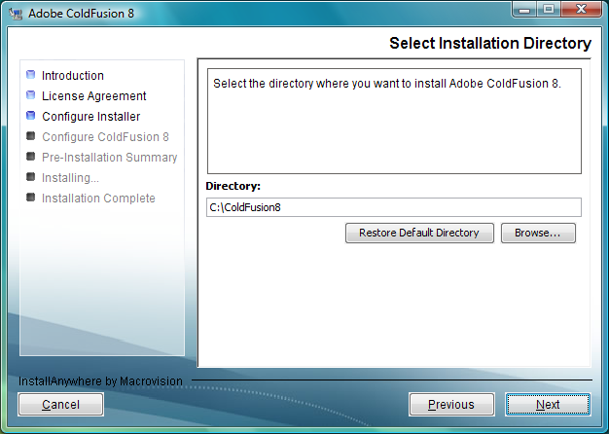

1. As you have chosen to install LiveCycle Data Services, you will need to agree to a further **Licence Agreement** screen. Click “Next”.

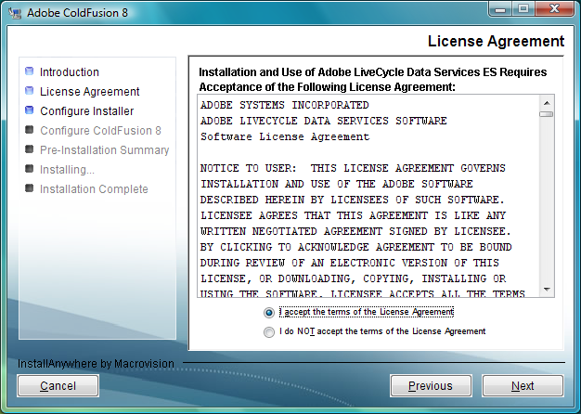

1. The **Adobe Livecycle Data Services ES Installation** screen is displayed. You will need to enter a serial number into this screen for production environments. Since I am going to assume a development environment, simply click “Next”.

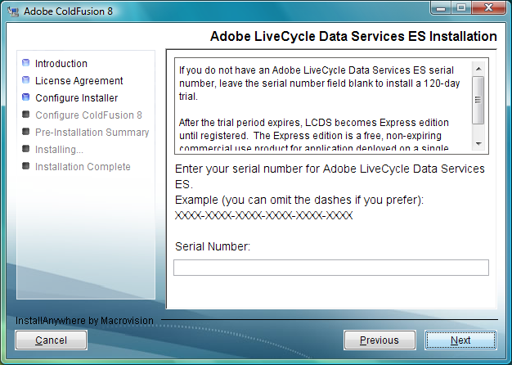

1. The **Configure Web Servers / Websites** screen should be displayed. This is the point where we want to connect ColdFusion with Apache. By default “Configure web server connector for ColdFusion” is checked. We need to add Apache so Click “Add”.

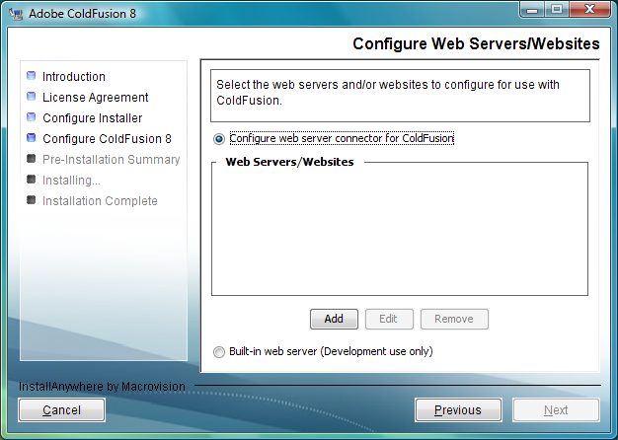

* 1. The **Add Web Server Configuration** screen is displayed, choose Apache from the drop-down.
  2. Add the relevant Apache directory paths, e.g.:

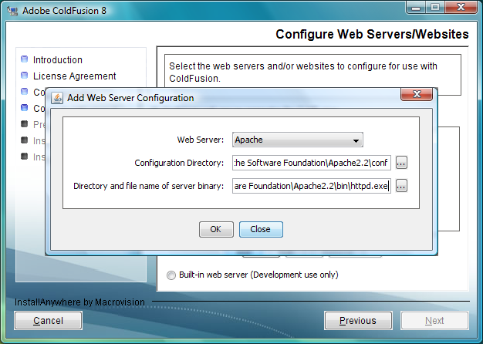

* + 1. The **Configuration Directory** C:\Program Files\Apache Software Foundation\Apache2.2\conf
    2. The **Server Binary Directory** C:\Program Files\Apache Software Foundation\Apache2.2\bin\httpd.exe

1. The **Review Configured Web Server** screen is then displayed. If all the settings are correct, click “Next”.

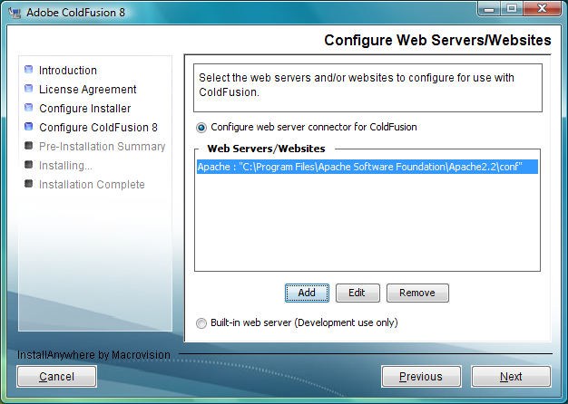

1. The **Choose Adobe ColdFusion 8 Administrator Location** screen should be displayed. Since we are using Apache for our web server then the default Directory should be pointing to C:\Program Files\Apache Software Foundation\Apache2.2\htdocs. You can alternatively point this to C:\WebRoot or wherever you have set up your web project files. Select “Next”.

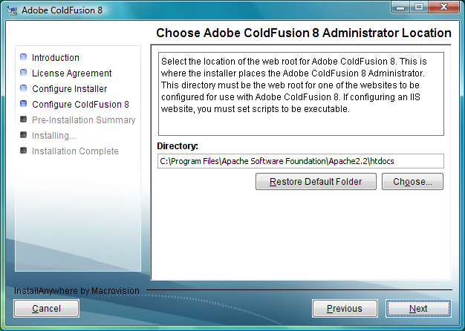

1. The **Adminstrator Password** screen is then displayed, prompting for a password. Enter one, remember it (!!) and click “Next”.

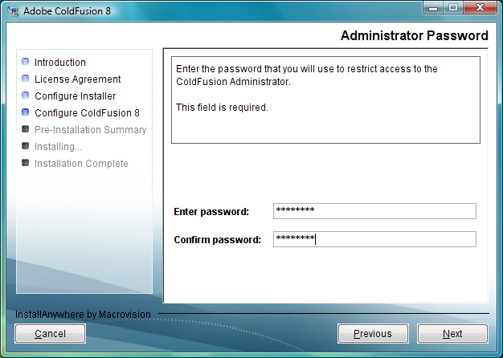

1. The **Enable RDS & Password** screen is then displayed. If you want to use this, check the box and provide an additional password. Don’t use RDS in a production environment. Click “Next”.

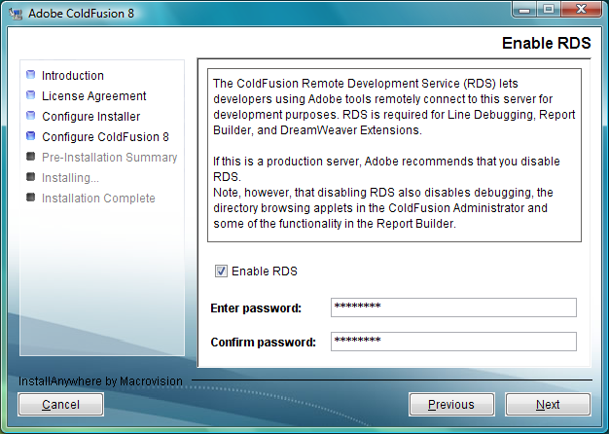

1. The **Pre-Installation Summary** screen is then displayed, detailing your configuration. This is your last chance to go back and make changes. If everything is OK, click “Install”.

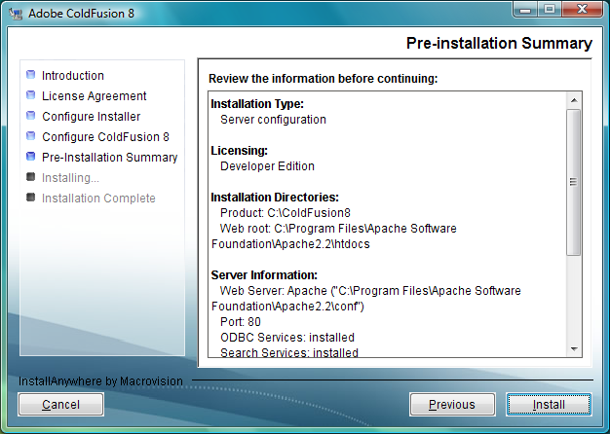

1. The **Installing Adobe ColdFusion 8** screen is then displayed, showing a host of marketing messages.

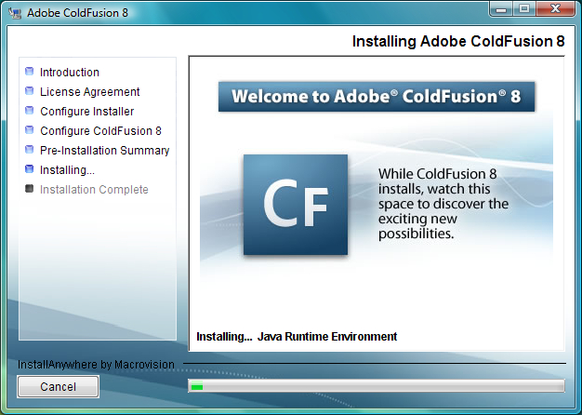

1. The **Please Wait** screen is displayed, and be prepared to wait!

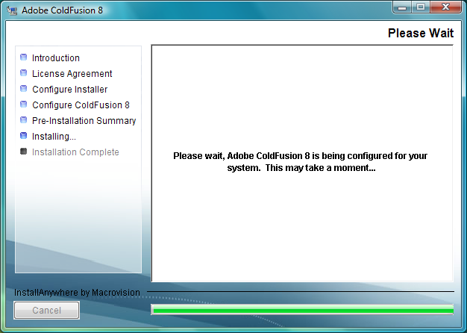

1. The **Installation Complete** screen is finally displayed and indeed the installation is complete. Now for the configuration! Click “Done”.

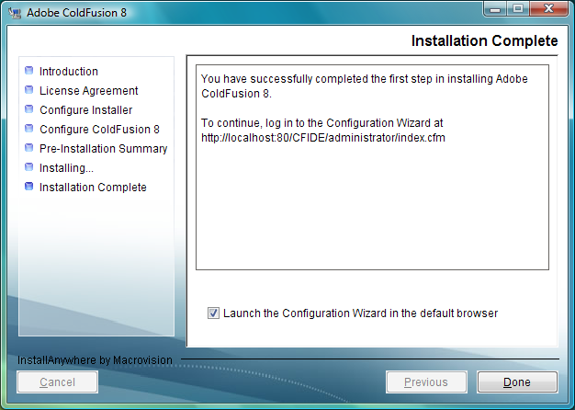

1. Configuration and Settings Migration Wizard. Open up a browser and enter the url http://localhost/CFIDE/administrator/index.cfm to begin the **ColdFusion 8 Configuration and Settings Migration Wizard**. Enter your password and Click “Login”.

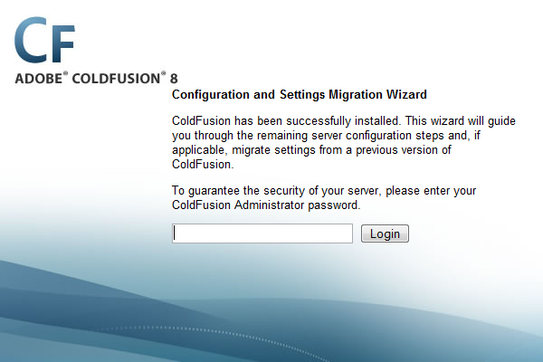

1. ColdFusion will now begin **Configuring Server**, which could take any number of minutes to complete.

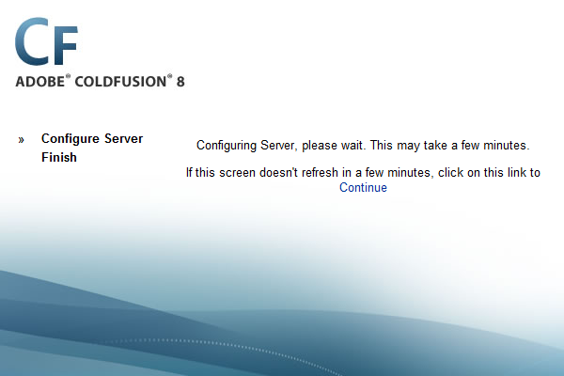

1. Once the **Configuration Complete** is displayed, you can login to the ColdFusion Administrator and start working, or playing, with the new interface, settings and Server Monitor.

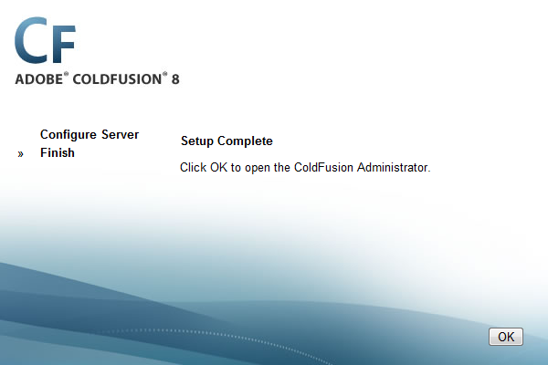

So, that only 22 steps! That may be the longest installation process you may go through, but the power now at your finger tips to produce hugely interactive websites is a compelling reason why to choose this version of ColdFusion, or indeed ColdFusion over other products.

**Configuring ColdFusion 8 with Apache**

16th November 2007 in [Apache](http://www.simonwhatley.co.uk/category/applications/apache-2), [Application Servers](http://www.simonwhatley.co.uk/category/applications/application-servers), [ColdFusion](http://www.simonwhatley.co.uk/category/code/coldfusion), [Web Servers](http://www.simonwhatley.co.uk/category/applications/web-servers) by [Simon](http://www.simonwhatley.co.uk/author/whatterz/) | [4 comments](http://www.simonwhatley.co.uk/configuring-coldfusion-8-with-apache#comments)

After installing ColdFusion 8 and Apache successfully you may still see an “HTTP 500 Internal Server Error” when navigating to a ColdFusion page. All is not lost, you simply need to configure, or check the configuration of Apache.

Apache requires very little post installation modification, but it is always good practice to check the *httpd.conf* file to ensure that the ColdFusion “install” scripts did what they were supposed to do.

If you haven’t confirmed that Apache is running, open your browser and point it to <http://localhost/> (unless you specified a real URL during installation). You should see the Apache test page. If you see an error, review the [Apache installation steps](http://www.simonwhatley.co.uk/installing-apache-on-vista) to make sure you followed all the steps correctly, and/or check your log files for more detailed errors.

Now we know Apache is running, but how about ColdFusion? Point your browser to the ColdFusion Administrator found commonly at <http://localhost/CFIDE/administrator/index.cfm> and see what happens. One of three possible failures could occur:

1. Your **browser prompts you to save the .cfm** file to your computer. There a couple of possible resolutions to this. Firstly restart the Apache service. If this does not resolve the issue you will need to check the *httpd.conf* file to ensure that the ColdFusion module is being loaded. The file can typically be found in the *C:\Program Files\Apache Software Foundation\Apache2.2\conf* directory.  
   Make sure that the DirectoryIndex has a reference to the index.cfm file (i.e. the default file):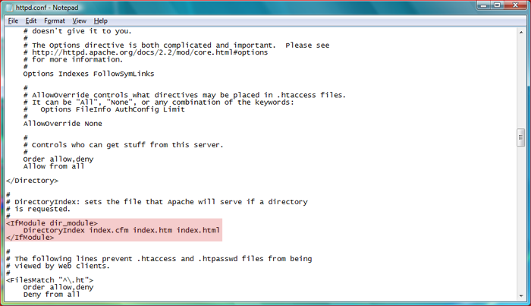Ensure that the LoadModule jrun_module "C:/ColdFusion8/runtime/lib/wsconfig/1/mod_jrun22.so" is also present:

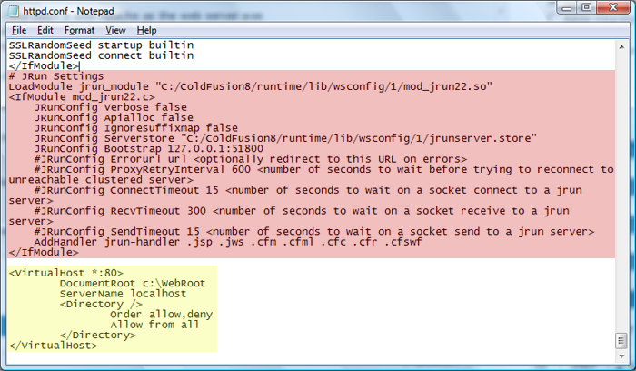

If you need to edit this file, restart the Apache service after you have saved the changes.

1. You get a message that **the CFIDE folder cannot be found**. This is more likely to be a problem with where you placed the ColdFusion application during install. The default location is in the Apache directory (*C:\Program Files\Apache Software Foundation\Apache2.2\htdocs*), so check in the http.conf file to ensure the DocumentRoot is pointing correctly. Alternatively, copy this folder to your localhost webroot (e.g. *C:\WebRoot*) ensuring that the DocumentRoot points to your webroot (see the yellow box in the second screen-shot).
2. You get another message which probably means that you need to reinstall ColdFusion, and/or Apache!

And that is it, you can start using ColdFusion and developing applications.